Program to Demonstrate the Sensitive ResultSet.

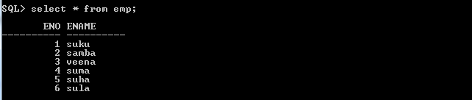

import java.sql.Connection;

import java.sql.DriverManager;

import java.sql.PreparedStatement;

import java.sql.ResultSet;

import java.sql.SQLException;

public class Sample {

public static String qur="select eno,ename from emp";

public static void main(String[] args) throws InterruptedException {

try(Connection con=DriverManager.getConnection("jdbc:oracle:thin:@localhost:1521:xe","sukumar","sukumar");

PreparedStatement s=con.prepareStatement(qur,ResultSet.TYPE_SCROLL_SENSITIVE,ResultSet.CONCUR_UPDATABLE);

){

if(s!=null) {

ResultSet r=s.executeQuery();

System.out.println("===========Top to Bottom==============");

int count=0;

while(r.next()) {

if (count==0)

Thread.sleep(40000);

r.refreshRow();

System.out.println(r.getRow()+"|"+r.getInt(1)+" "+r.getString(2));

count=count+1;

}

}

}

catch(SQLException e) {

}

}

}

Output:-

----------



Program is waiting for 4 seconds.

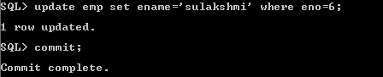

1|1 suku

2|2 samba

3|3 veena

4|4 suma

5|5 suha

6|6 sulakshmi